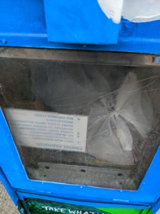

July 7, 2020

To all:

I hope this email finds you and your family safe and healthy. As we are in full summer mode, I wanted to let everyone know where we are with the Little Free Pantry food distribution. At the last Zoom meeting, we decided that with the funds donated we would distribute grocery cards to families as the safest and most efficient way to have perishables bought as needed. Mercer Street Friends obtained 400 Shop-Rite Grocery Cards in $25.00 denominations. (Yes we received a discount-shhh! I am not sure others are supposed to know this.)

On June 29, 2020 Janis Todd and I handed out 140 of the cards to families that drove through a food distribution at West Windsor-Plainsboro High School North. The District is providing meals to families in an efficient “drive through” procedure- families were checked in, received milk and cookies as they lasted, the grocery store cards, apples, lemons and boxes of food. An additional 20 cards from LFP were given to the District for distribution to families who have bus delivery of their food. A shout out to the Girl Scouts- Ana and Sahana who folded, stuffed and stamped envelopes with the 400 cards. We placed a flyer and a card in each envelope telling families about the Little Free Pantry. The flyer was/is in English, Spanish, Chinese and Hindi. A thank you to our team of translators- Janis, Jyotima and Yan Mei!

Our next distribution of grocery store cards will be on July 13 from 9 to 1 at West Windsor-Plainsboro High School North. We have no way of knowing how many families will be driving by on that day but we have many cards yet to be handed out so we think all families coming next week will receive a card.

Given the circumstances of Cronvid-19 and the uncertainty of what will be happening as we move in phases to reopen businesses, schools and religious organizations, we will continue to seek donations for the LFP and continue to give those in need store cards. Thank you to all who have donated. Literally hundreds of people have been helped.

I will be sending out a Zoom Meeting notice in the next few days.

Cheers!

Melissa Hager

